Dis-Afr-Aterian Tanged Points-North Africa-Magreb Region-Middle Stone Age -100-85 ky.

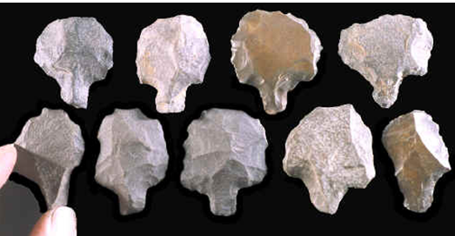

**Formal Label: Aterian Culture Tanged Points of the Magreb Region of North Africa**

**Alpha-Numeric Identifier:** GN772.2.A78/QM434

**Date or Time Horizon:** 100 ka-30 ka

**Geographical Area:** Maghreb region of North Africa

**Cultural Affiliation:** Aterian

**Medium:** Flint, Silicified limestone

**Dimensions:** H 1-3 in

**Weight: varies**

**Provenance:** Morocco

**Condition: Museum**

**Discussion:**

The Aterian techno-complex has a geographic distribution in North Africa from the Mahgreb to the Western Desert of Egypt with only one site on the Nile valley (Wendorf and Schild, 1992). The Aterian generally follows the Mousterian in the Maghreb stratigraphically (Tixier, 1967; Petit-Maire, 1982; Tillet, 1987; Raimbault,1988) encompassing the Atlas Mountains (Berber: idurar n’ Watlas, Arabic: جبال الأطلس‎) in Morocco, Algeria, and Tunisia with a range of 2,500 km (1,600 mi). In the Eastern Sahara it follows the Levallois.

Aterian tanged points tools were a combination of two raw materials, (tanged stone point and a wooden shaft) producing a composite tool used for hafted knives or scrapers with alternating active edges, rather than used for hafted weapons. The evidence for an early invention and increasing prevalence of hafted tools is mounting, both in Europe, among Neanderthals (e.g., [71,72]) and in Africa, among anatomically modern humans ([73,74]). In light of this evidence, it is perhaps more appropriate to treat the ‘Aterian question’ in terms of an early innovation in hafting, rather than in projectile use, or, indeed, in weapon use at all. And if that

is the case, we must ask what prompted the invention of the hafting insert. It could be speculated that the invention of this distinguishing feature of the Aterian, the tang, was associated with a move into increasingly arid zones of the Sahara [19,20,75], where the lack of resin-bearing trees could have created the need for a hafting insert adapted for use with bindings (but see [73] for evidence of an increase in the use of resin for hafting in southern Egypt in the Upper Pleistocene and [76,77] for an ethnographic account of spear-hafting using resin in the Australian desert). It is as yet unclear if gum-yielding plants would have been available in the more arid zones of North Africa 100 thousand years ago, but it makes sense that a tang allows for an easier hafting using leather bindings, since it provides a less sharp and more regular surface to wrap around. The Aterian culture is found across North Africa (see Map) and is differentiated from the Mousterian and essentially defined by the presence of these tanged (stemmed) tools.

The Middle Paleolithic chronology of the Maghreb region of North Africa is poorly known because of the paucity of sites with a long stratigraphy and the limited number of available radiometric dates. In this paper, we report the age-estimates obtained by the TL and OSL methods on sediments and burnt lithic samples from the Rhafas Cave in Eastern Morocco. The Mousterian is largely earlier than 100 ka, that the latest Mousterian dates to OIS 5 between 90–80 ka and the Mousterian to Aterian transition occurred about 70–80 ka, at the end of OIS 5 or during OIS 4. These dates will be most useful in the construction of a chronological framework of this unique sequence and for the interpretation of paleo-environmental information.

**References:**

# Mercier, N, L. Wengler, H. Valladas, J.-L. Joron, L. Froget, J.-L. Reyss. 2007. The Rhafas Cave (Morocco): Chronology of the Mousterian and Aterian archaeological occupations and their implications for Quaternary geochronology based on luminescence (TL/OSL) age determinations, [*Quaternary Geochronology*](http://www.sciencedirect.com/science/journal/18711014), 2:4, 309-313.